# BANK LOAN REPORT QUERY DOCUMENT

## BANK LOAN REPORT SUMMARY

## **KPI’s:**

### Total Loan Applications

select count(id) as Total_Clients from financial_loan;

Output:



### Month-to-Date (MTD) Loan Applications

select count(id) as MTD_total_loan_application from financial_loan where month(issue_date) = 12 and year(issue_date) =2021;



### Previous MTD Loan Applications

select count(id) as previousMTD from financial_loan where month(issue_date) =11 and year(issue_date)= 2021;



### MTD Total Funded Amount

select sum(loan_amount) as MTD_total_funded_amount from financial_loan where month(issue_date)=12 and year(issue_date)=2021;



### PMTD Total Funded Amount

select sum(loan_amount) as Previous_MTD_total_funded_amount from financial_loan where month(issue_date)=11 and year(issue_date)=2021;



### Total Amount Received

select sum(total_payment) as Total_Amount_received from financial_loan;



### MTD Total Amount Received

select sum(total_payment) as MTD_Amount_received from financial_loan where month(issue_date)=12 and year(issue_date)= 2021;



### PMTD Total Amount Received

select sum(total_payment) as PMTD_Amount_received from financial_loan where month(issue_date)=11 and year(issue_date)= 2021;



### Average Interest Rate

select round(avg(int_rate)*100 ,2,2) as avg_intr_rate from financial_loan ;



### MTD Average Interest Rate

select round(avg(int_rate)*100,2,2 )as MTD_avg_intr_rate from financial_loan where month(issue_date)=12 and year(issue_date)=2021;



### PMTD Average Interest Rate

select round(avg(int_rate)*100,2,2) as PMTD_avg_intr_rate from financial_loan where month(issue_date)=11 and year(issue_date)=2021;

### Average Debt-to-Income Ratio(DTI)

### select round(avg(dti)*100,2,2) as MTD_avg_DTI from financial_loan;



### MTD Average Debt-to-Income Ratio(DTI)

select round(avg(dti)*100,2,2) as MTD_avg_DTI from financial_loan where month(issue_date)=12 and year(issue_date)=2021;



### PMTD Average Debt-to-Income Ratio(DTI)

select round(avg(dti)*100,2,2) as PMTD_avg_DTI from financial_loan where month(issue_date)=11 and year(issue_date)=2021;



### GOOD LOANS

select count(loan_status) as good_loans from financial_loan where loan_status in ('fully paid','current');



### GOOD LOANS PERCENTAGE

select (count(case when loan_status in ('fully paid','current')then id end)*100)/

count(id) as percentage_of_good_loans from financial_loan;



### GOOD LOANS FUNDED AMOUNT

select sum(loan_amount) as good_loans_funds from financial_loan where loan_status in ('fully paid','current');



### GOOD LOANS FUNDED AMOUNT

select sum(total_payment) as good_loans_payment from financial_loan where loan_status in ('fully paid','current');



### BAD LOANS

select count(loan_status) as bad_loans from financial_loan where loan_status = 'charged off';



### BAD LOANS PERCENTAGE

select count(case when loan_status='charged off' then id end)*100 / count(id) as Bad_loans_perc

from financial_loan;



### BAD LOANS FUNDED AMOUNT

select sum(loan_amount) as Bad_loans_funds from financial_loan where loan_status ='charged off';



### BAD LOAN TOTAL RECEIVED AMOUNT

select sum(total_payment) as Bad_loans_payment from financial_loan where loan_status ='charged off';



## LOAN STATUS

select

loan_status,

count(id) as Total_loan_applications,

sum(total_payment) as Total_amount_paid_back,

sum(loan_amount) as Total_funded_amount,

round(avg(int_rate)*100,4) As Interest_rate,

round(avg (dti*100),4) as DTI

from

financial_loan

group by loan_status;

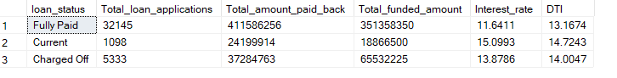

select

loan_status,

sum(total_payment) as MTD_total_amount_received,

sum(loan_amount) as MTD_total_funded_amount

from financial_loan

where month(issue_date)= 12

group by loan_status;

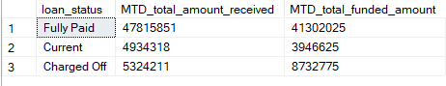

# DASHBOARD 2:

### Monthly Trends by issue Date

select

month(issue_date) as month_no,

datename(month, issue_date) as month,

count(id) as total_loan_applications,

sum(loan_amount)as total_funded_amount,

sum(total_payment) as total_amount_received

from financial_loan

group by month(issue_date),datename(month, issue_date)

order by month(issue_date);

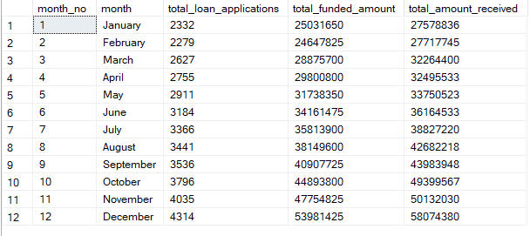

### Regional Analysis by State

select

address_state,

count(id) as total_loan_applications,

sum(loan_amount)as total_funded_amount,

sum(total_payment) as total_amount_received

from financial_loan

group by address_state

order by sum(loan_amount) desc;

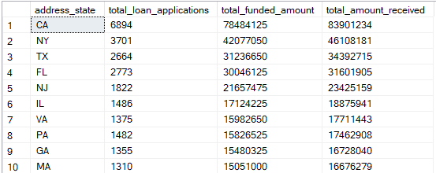

### Loan Term Analysis

select

term,

count(id) as total_loan_applications,

sum(loan_amount)as total_funded_amount,

sum(total_payment) as total_amount_received

from financial_loan

group by term

order by term;

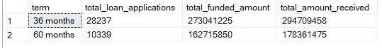

### Employee length Analysis

select

emp_length,

count(id) as total_loan_applications,

sum(loan_amount)as total_funded_amount,

sum(total_payment) as total_amount_received

from financial_loan

group by emp_length

order by emp_length;

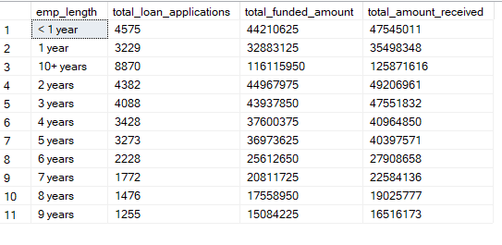

### Loan Purpose Breakdown

select

purpose,

count(id) as total_loan_applications,

sum(loan_amount)as total_funded_amount,

sum(total_payment) as total_amount_received

from financial_loan

group by purpose

order by purpose;

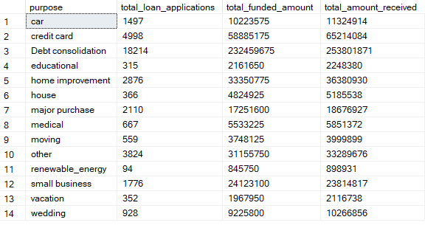

### Home Ownership Analysis

select

home_ownership,

count(id) as total_loan_applications,

sum(loan_amount)as total_funded_amount,

sum(total_payment) as total_amount_received

from financial_loan

group by home_ownership

order by home_ownership;

